Project Name: E-commerce for farm product mango.

***Mangoezzz…***

Brief Summary:

The system introduces, promote and manage mangoes of different GI tags India at one place. This system ensures that the end user get the fresh product directly from the farmer for the best market price by cutting middle man costs.

System allow authenticated user to order mangoes of different GI tags from their places by selecting as per availability mangoes of different variety.

Farmers get verified by using different GI tag location only verified farmers are allowing to register which will give assurance to customer that they get the good quality mangoes.

Authenticated farmer (seller) will modify the product details and delivery details (drop shipping at seller end) as per availability and status will update on platform.

Admin can access all the functionalities of customer and seller. Admin can manage inventory of, monitor order and sales reports.

Actors:

Admin

Customer

Seller (Farmer)

Use Case (Functionality):

Customer:

1)Authentication (login / Registration)

2)view product

3)order product

4)cancel order (condition before dispatch only)

5)confirm order

Farmer:

6)add product

7)remove product

8)delivery of product //update on portal reflect on customer and seller side drop shipping service

9)sale of farmer

Admin:

10)view customers

11)view sellers

12)current orders reports

13)total sale 14)verify farmer using GI tag region

Pages:

1)Home page

2)login/ registration page

3)order page

4)product view page

5)billing page/including all details of user

6)about us with farm pic

7)contact/ help

Product (mangoes selected as per GI tags)

1)Alphonso (The Konkan region comprising Palghar, Thane, Raigad, Ratnagiri and Sindhudurg districts, Maharashtra)

2)Gir Kesar (Junagadh (Around Gir Forest) Gujarat)

3)Marathwada Kesar (Marathwada Division (Aurangabad, Nanded, Parbhani, Latur, Beed, Hingoli, Jalna and Osmanabad) Maharashtra)

4)laxman bhog ( Malda , West Bengal)

5)Salem mango (Krishnagiri, Salem, Namakkal, Dharmapuri ,Tamil Nadu)

Use Case Diagram:-

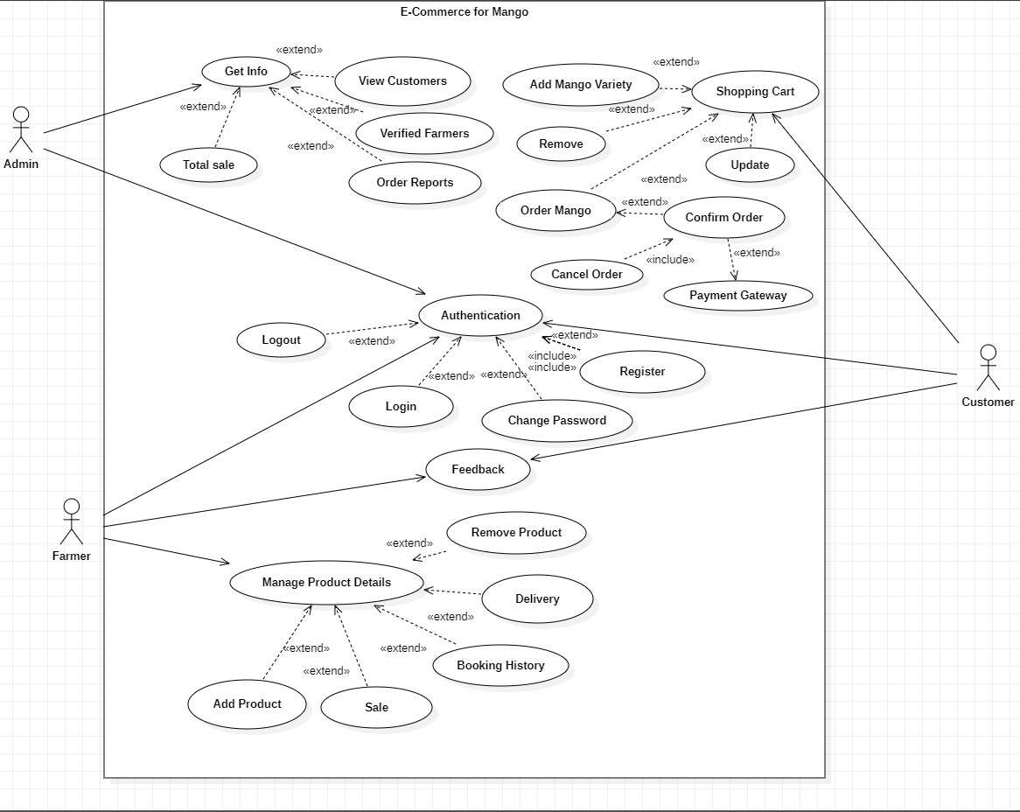

Future Scope: -

system provide the business statistic which will help farmer to promote, manage sales data, and can improve performance in sales using PowerBI.